Each software needs to embrace a certain number of characteristics.

**Characteristics of a Software**

* Maintainable and Extendable
* Testable
* Understandable for new developers

Let’s take a look at what does each characteristic means.

**Maintainable Software:**

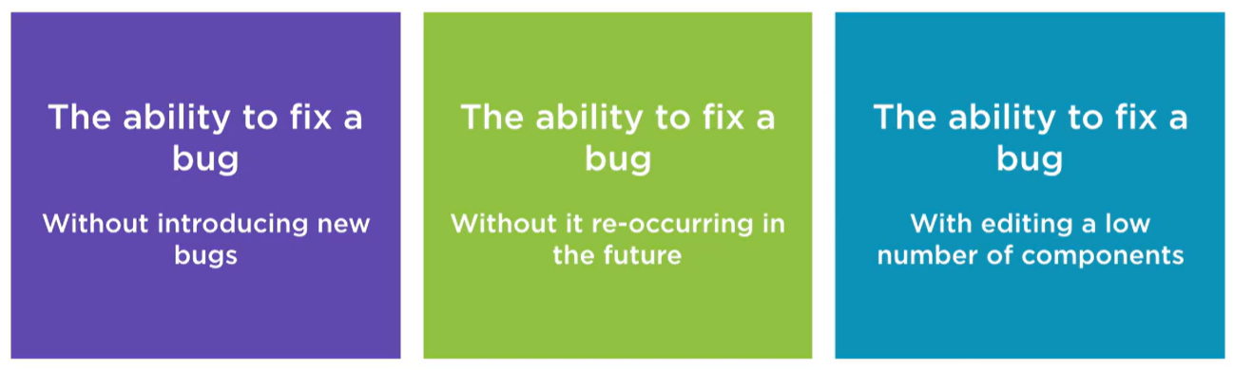

**Extendable Software:**

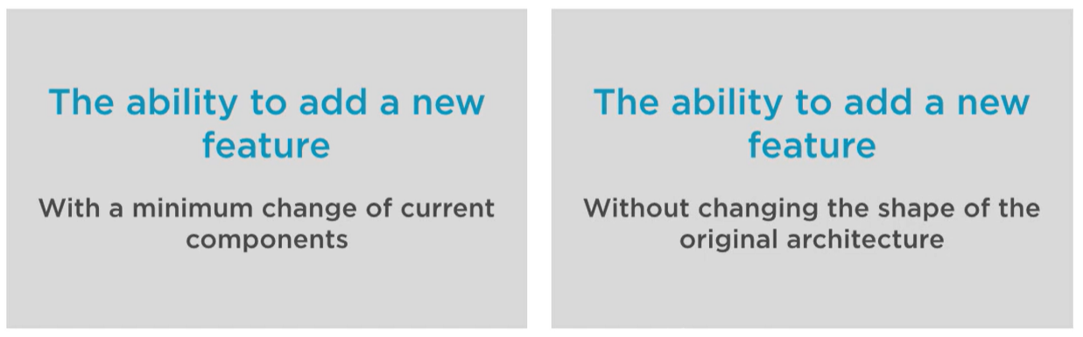

**Testable Software:**

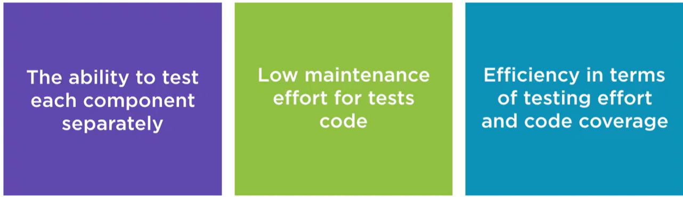

**Understandable for new Developers (Stakeholders):**

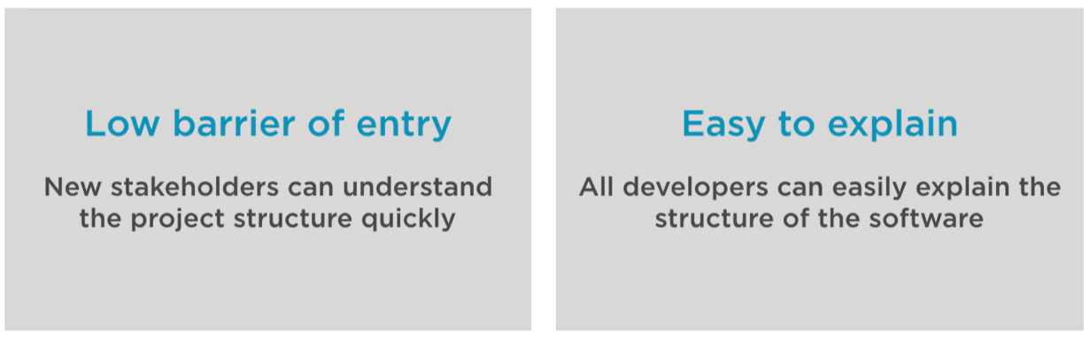

*“Truth can only be found in one place:*

*the code.”* -Robert C. Martin

**Evaluating the complexity of Android Applications**

Android applications may seem very simple from the outside but they can become quite complex on the inside.

* Can become very complex
* High number of core components
* High number of libraries
* Have restrictions from the OS
* Components have to comply to restrictions

**A typical Android Application**

A typical android application seemingly simple can have huge number of components in it. To get a better idea, look at the following structure of a typical android application

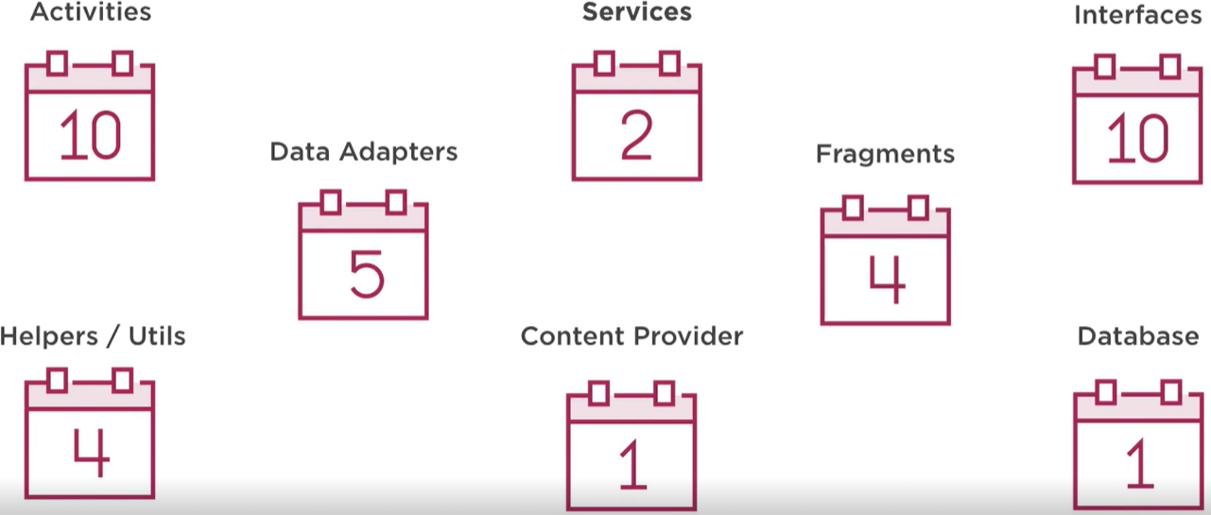

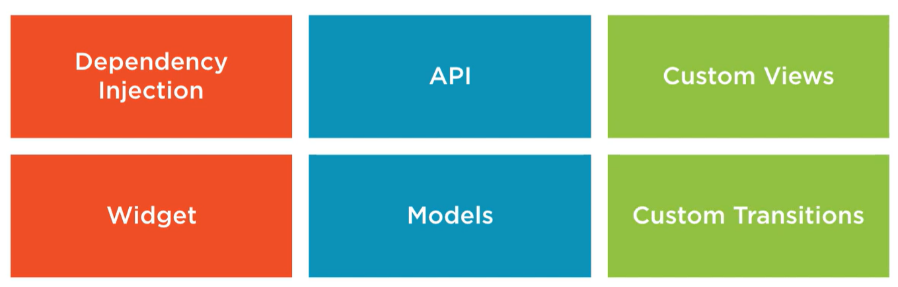

**Interoperability between Components**

Another important feature of android applications is interoperability between different components. To effectively use and implement this, it must be:

* Highly decoupled from each other
* Able to consistently communicate with each other